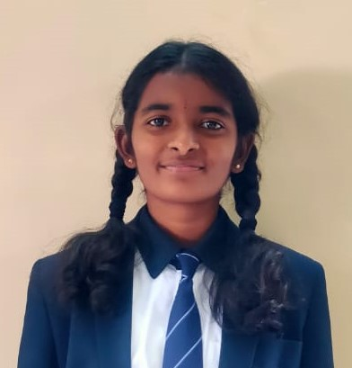

**DIVIJA S ACHARYA**

**HOUSE CAPTAIN – MARENGO**

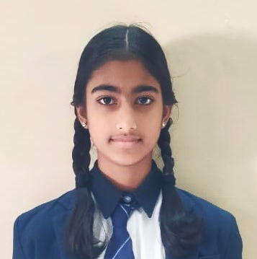

**CHARVI A**

**HOUSE VICE CAPTAIN – COPENHAGEN**

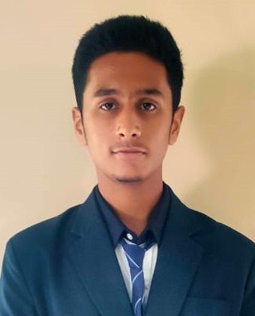

**DAANISH IMRAN KHAN**

**SCHOOL SPORTS CAPTAIN**

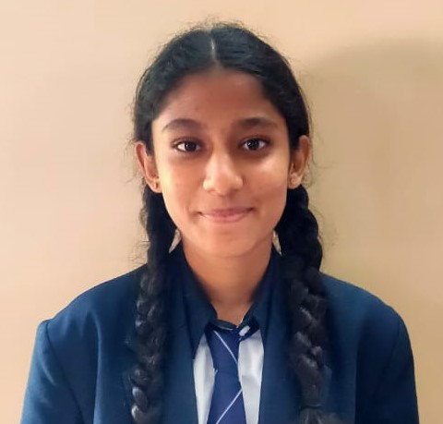

**BHOOMIKA S GOWDA**

**SCHOOL VICE CAPTAIN**

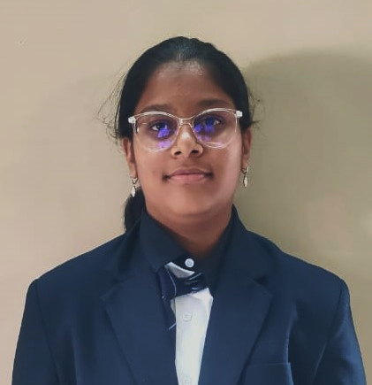

**AVIKA**

**HOUSE VICE CAPTAIN – PALOMO**

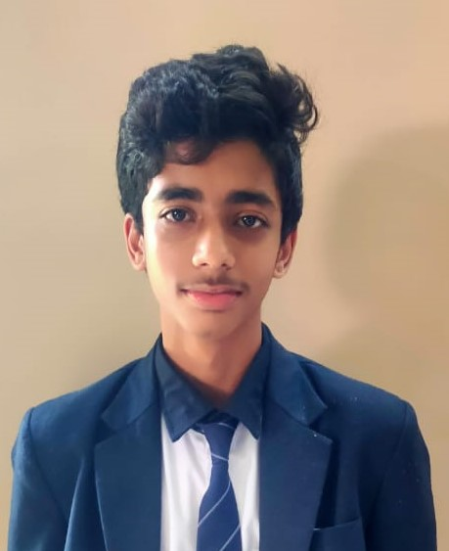

**ASHMITH AVINASH KALWANI**

**SCHOOL SPORTS VICE CAPTAIN**

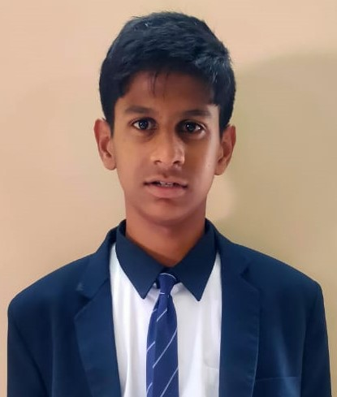

**SHEZAN IMRAN KHAN**

**HOUSE CAPTAIN – COPENHAGEN**

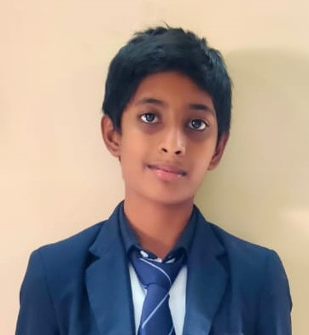

**PRATEEK REDDY S**

**HOUSE CAPTAIN – ECLIPSE**

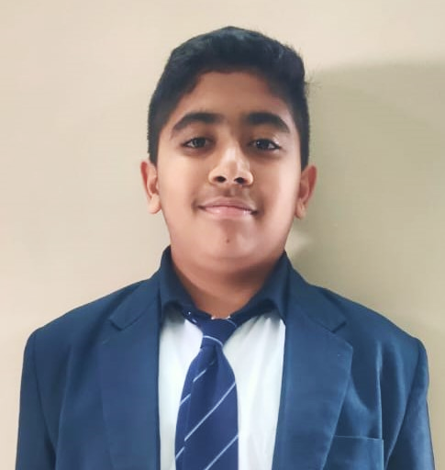

**N KRISH CHORDIA**

**HOUSE CAPTAIN – PALOMO**

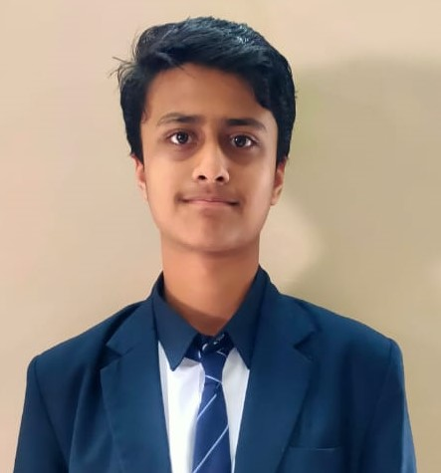

**KANHA SHANBHAG**

**VICE CAPTAIN- MARENGO**

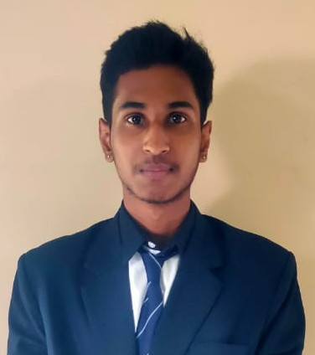

**G THANOJ KUMAR**

**SCHOOL CAPTAIN**